DEPARTMENT OF CHEMISTRY
GCW (A), GUNTUR
CERTIFICATE COURSE
IN
METHODS OF CHEMICAL ANALYSIS (2-CHE-CC1)

2023-24
(A 30hrs course from 27-01-2024 to 28-02-2024)

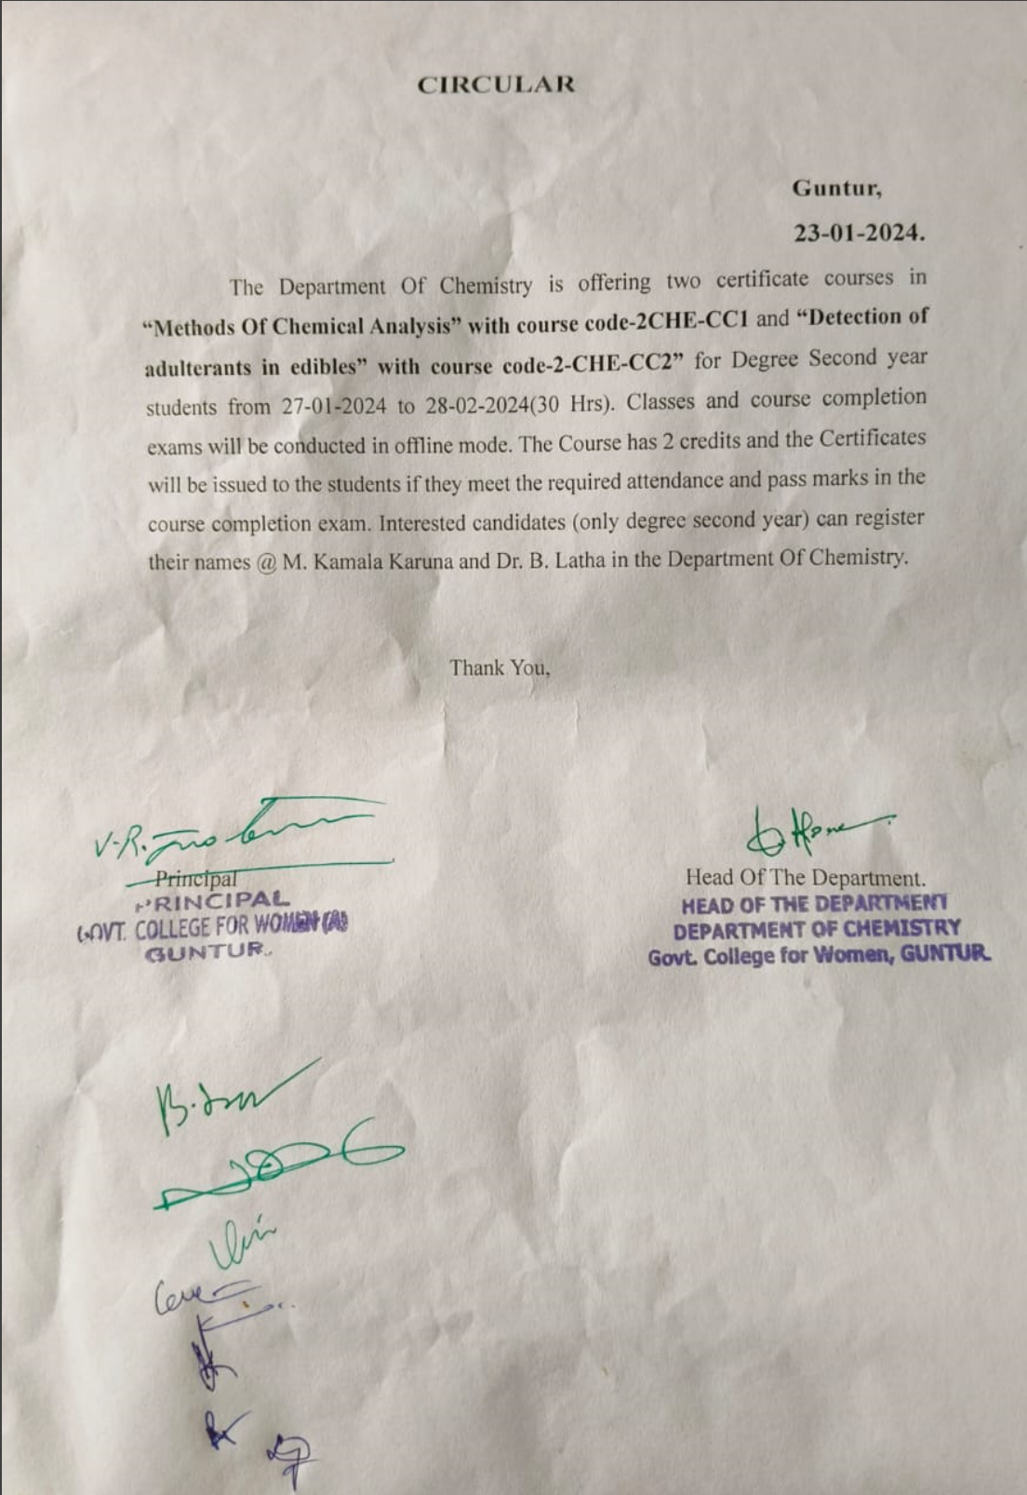

List Of Students Enrolled
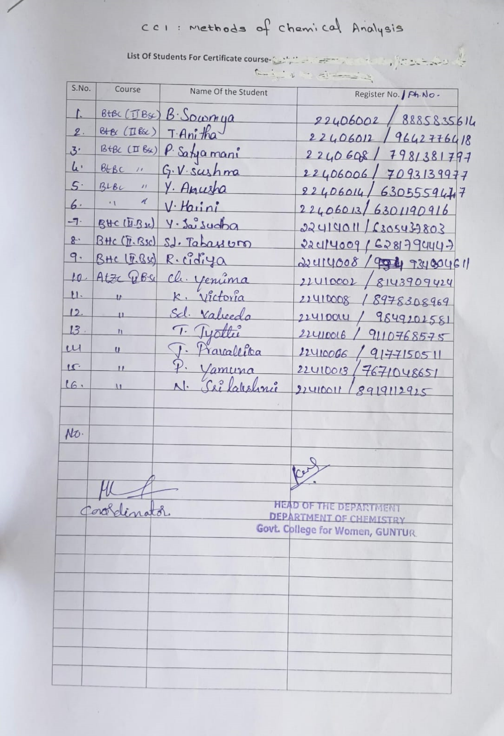

Certificate Course in Methods Of Chemical Analysis
(2-CHE-CC1)
Objective: To understand the different methods of chemical analysis.
To acquire knowledge about the working principles and their calibration.
Need of the hour and Context: To equip students with the analytical skills and training required for different areas of analytical chemistry like environmental sample testing, food and drug analysis, forensic sample testing.
Program in Brief: A certificate course in methods of chemical analysis was conducted from February 7^{th,} 2024 to March 15^{th,} 2024. Classes and lab sessions were taken from 9-10 am. 16 students were enrolled in this course. In this course, students learned about the classical methods of analysis and instrumental methods of analysis. Steps in chemical analysis and calibration of instruments and their working principles. On the 9th of February 2024, we visited the instrumentation lab of Shree Icon Labs, Vijayawada as they are conducting training for internship students in our college. We visited the regional soil testing laboratory, Guntur, so, as to gain knowledge about the various instruments used in the analysis of soil samples.
Students were asked to submit an assignment on the calibration of instruments pH meters and conductometer. An assessment test was conducted on 14-03-24. Two credits were given to this course. A total of 10 students have completed the course fulfilling the requirements. certificates were issued to them.
Eligibility for the Course
Candidates for admission to the certificate course in Water Analysis must be the students of 2nd year Degree program.
Duration of the Course: 30 Working days, 30 hours.

SYLLABUS
Government College for Women (A), Guntur
Department of Chemistry
CERTIFICATE, MULTIDISCIPLINARY, AECC, AND LIFE SKILL COURSES
Certificate Course-1 – METHODS OF CHEMICAL ANALYSIS (2-CHE-CC1)
UNIT-1
Classification of analytical methods------3H
Introduction and need for chemical analysis - Classical methods of analysis-modern methods of analysis – types of instrumental methods of analysis.
UNIT -2
Steps in chemical analysis ----------------4H
Selection of analytical method-stages in chemical analysis – interpretation of analytical data- accuracy and precision -calibration of instruments- analytical balance, conductometer- pH meter, potentiometer, colorimeter.
Unit-III
Working Principle and Instrumentation-----3H
Colorimeter, pH meter, potentiometer, conductometer, paper chromatography and TLC
Duration of the course: 30 hours (during III/V SEM in October)
Theory: 10 hrs.
Practical: 12 hrs.
Field visit: 6 hrs.
Exam: 2hrs
References:
1. Analytical Chemistry ---By R.M.Varma
2. Fundamentals Of Analytical Chemistry-Skoog
3. An Introduction to Chromatography-Trevor
4. Analytical Methods in Pharmacy-Dr.Suresh M.Jain and Patel
Timetable and Topics Covered:

S.No. | Date | Topic | Taken By
1 | 7/2/2024  5-6pm | Introduction and need for chemical analysis | All the members of the Department
2 | 9/2/2024  4-5pm | Types of instrumental methods of analysis | M.Kamala Karuna
3 | 12/2/2024  5-6pm | stages in chemical analysis- accuracy and precision | M.Kamala Karuna
4 | 13/2/2024  5-6pm | calibration of instruments | M.Kamala Karuna
5 | 14/2/2024  5-6pm | Working Principle Of Colorimeter, pH meter. | M.Kamala Karuna
6 | 15/2/2024  5-6pm | Working Principle Of potentiometer, conductometer. | M.Kamala Karuna
7 | 16/2/2024  5-6pm | Working Principle of Paper Chromatography and TLC | M.Kamala Karuna
8 | 17/2/2024  5-6pm | Estimation Of K2Cr2O7 using colorimeter. | K.Anusha
9 | 19/2/2024  5-6pm | Estimation Of K2Cr2O7 using colorimeter. | K.Anusha
10 | 20/2/2024  5-6pm | Estimation Of Iron by potentiometric titration | K.Anusha
11 | 21/2/2024  5-6pm | Estimation Of Iron by potentiometric titration | K.Anusha
12 | 22/2/2024  5-6pm | Estimation Of Iron by potentiometric titration | K.Anusha
13 | 23/2/2024  5-6pm | Estimation Of Iron by potentiometric titration | K.Anusha
14 | 24/2/2024  5-6pm | Estimation Of HCl by Conductometric titration | K.Anusha
15 | 01/3/2024 5-6pm | Separation Of Aminoacids by TLC | K.Anusha
16 | 02/3/2024  5-6pm | Separation Of Aminoacids by TLC | K.Anusha
17 | 04/3/2024  5-6pm | Separation of Plant Pigments By paper chromatography | K.Anusha
18 | 05/3/2024  5-6pm | Assignment
19 | 12/3/2024  5-6 pm | Visit to Soil testing lab in Guntur.
20 | 14/3/2024  3-4 pm | Written Test
21 | 18/3/2024  4-5 pm | Certificate Distribution

Inauguration and Classes:

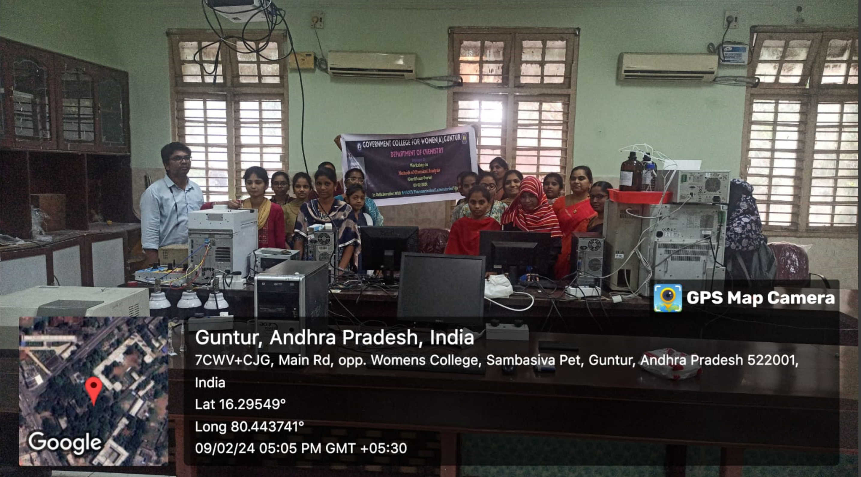
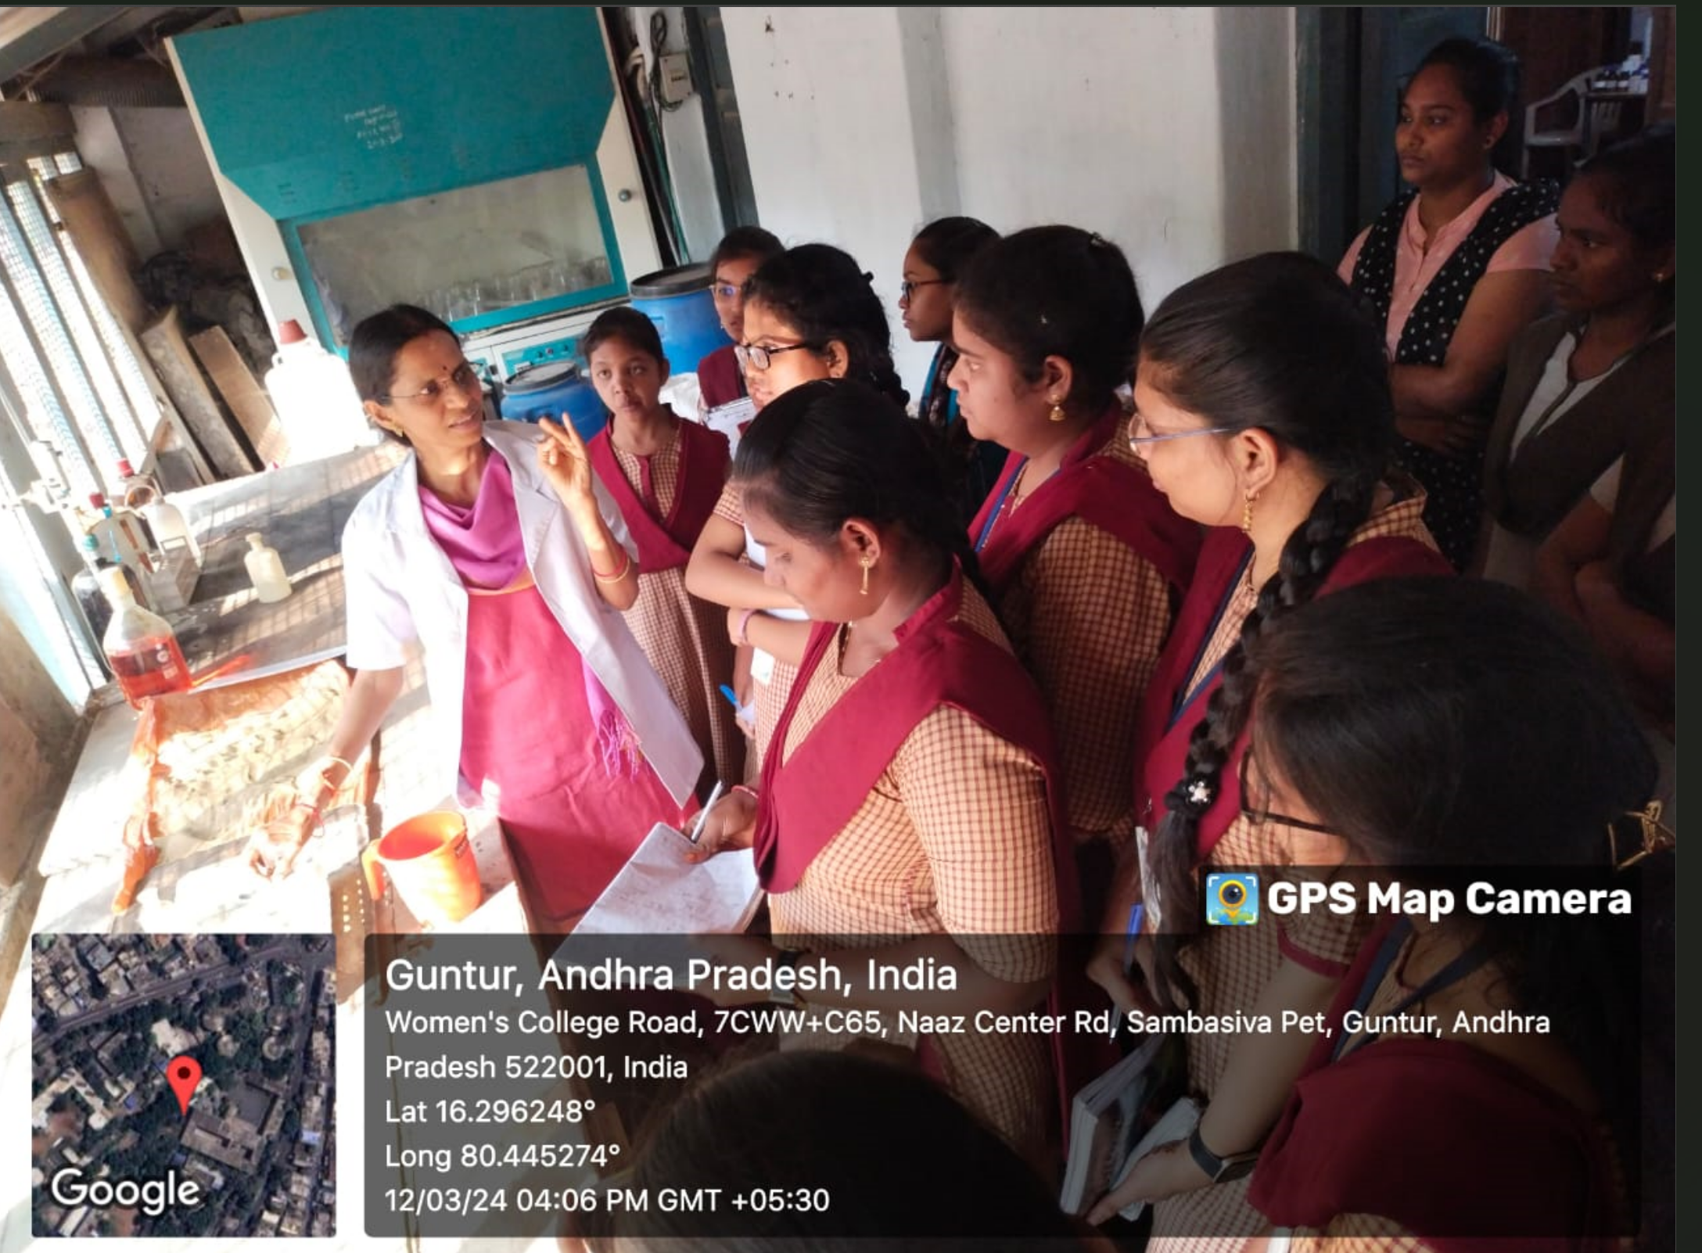

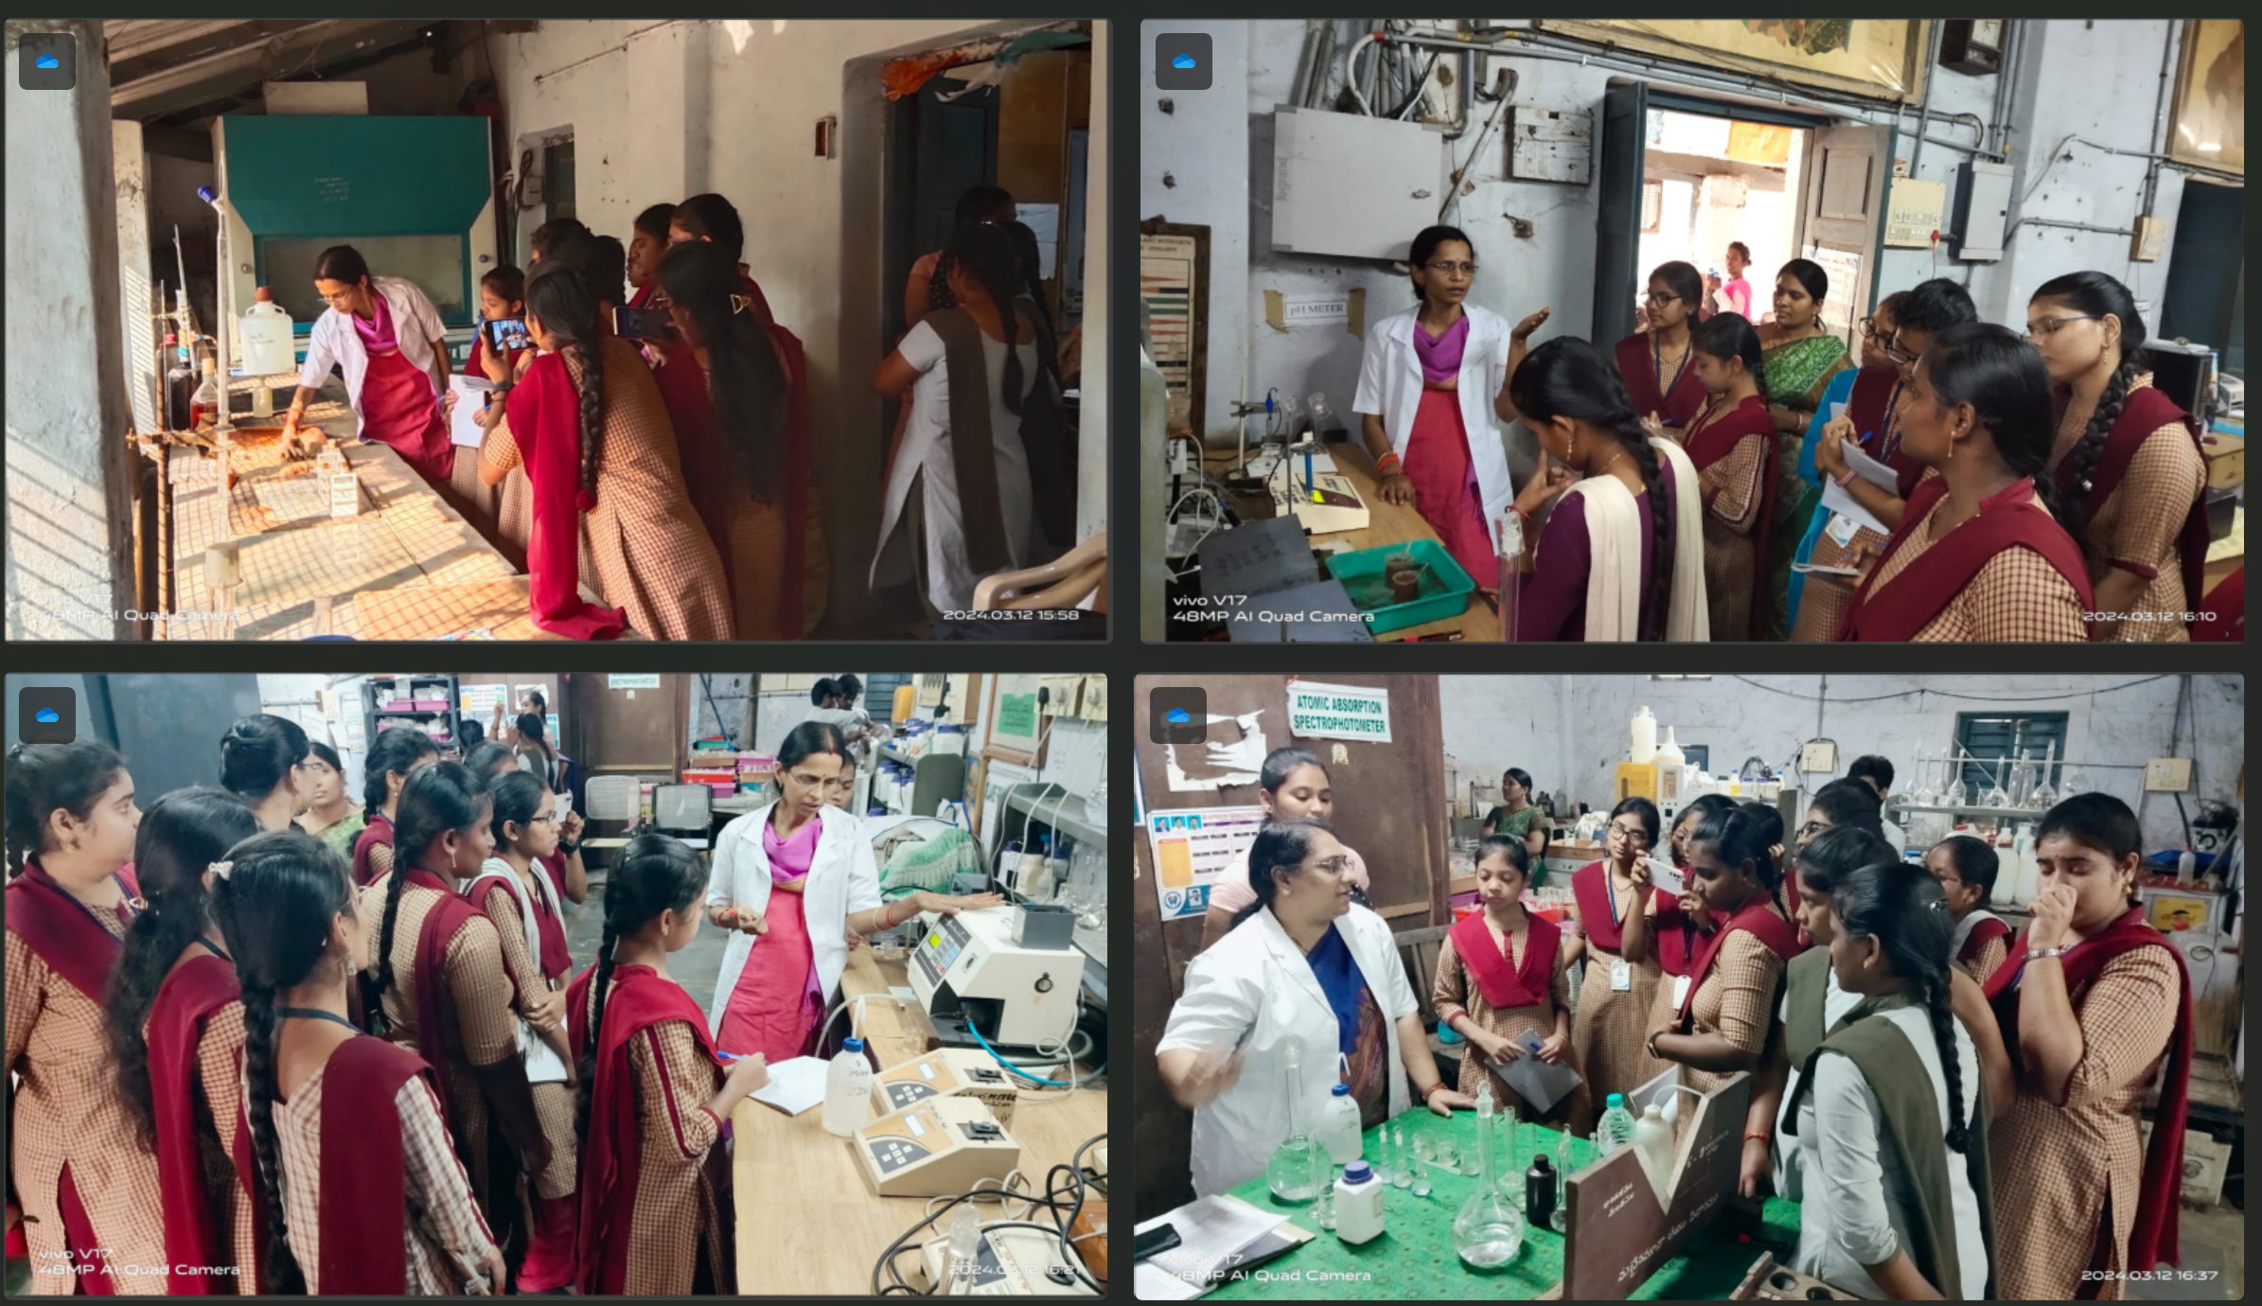

Attendance:
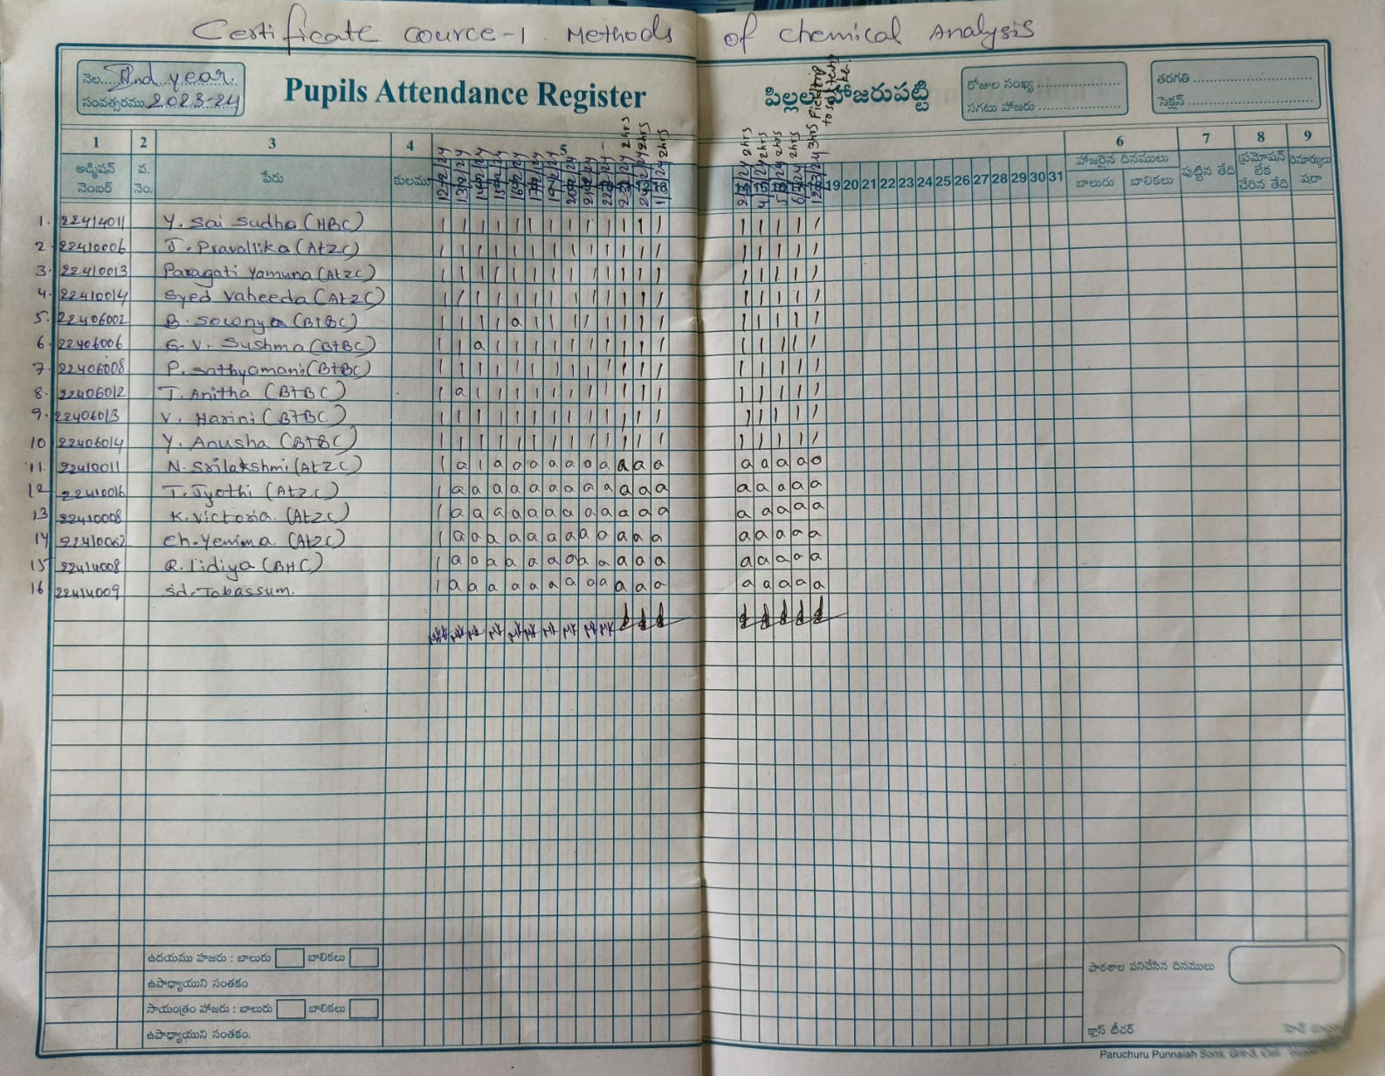

Written Test:
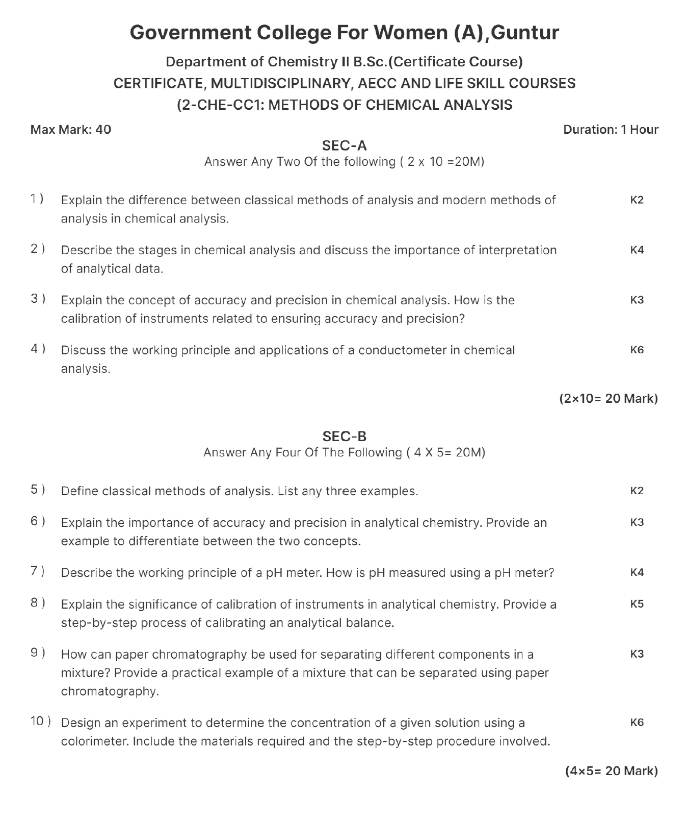

Assignment:
Answer any one of the questions.
1. What is the need for the Calibration of Conductivity meter?
2. Write about the calibration of the Ph meter.

Result:
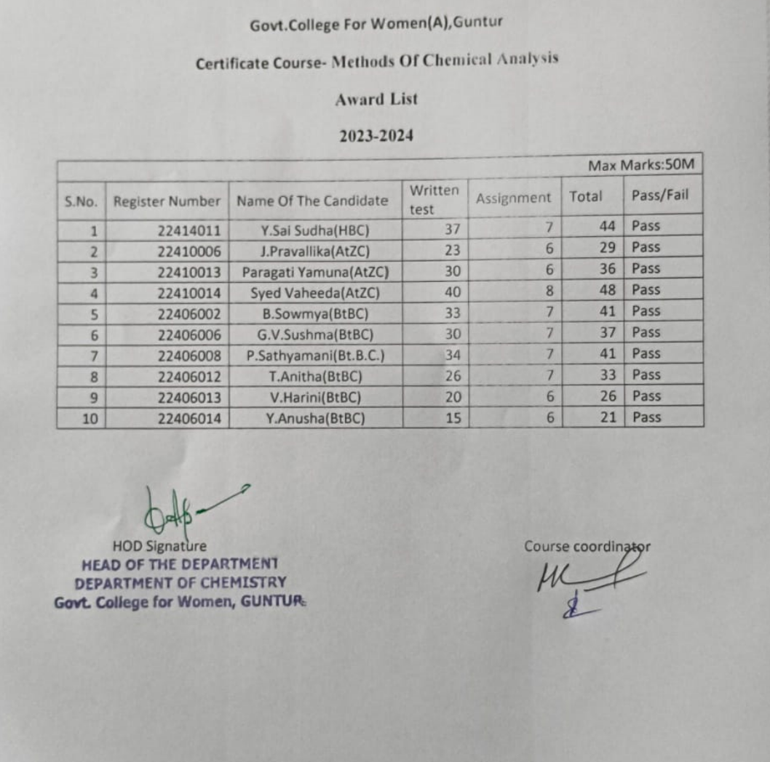

Certificates: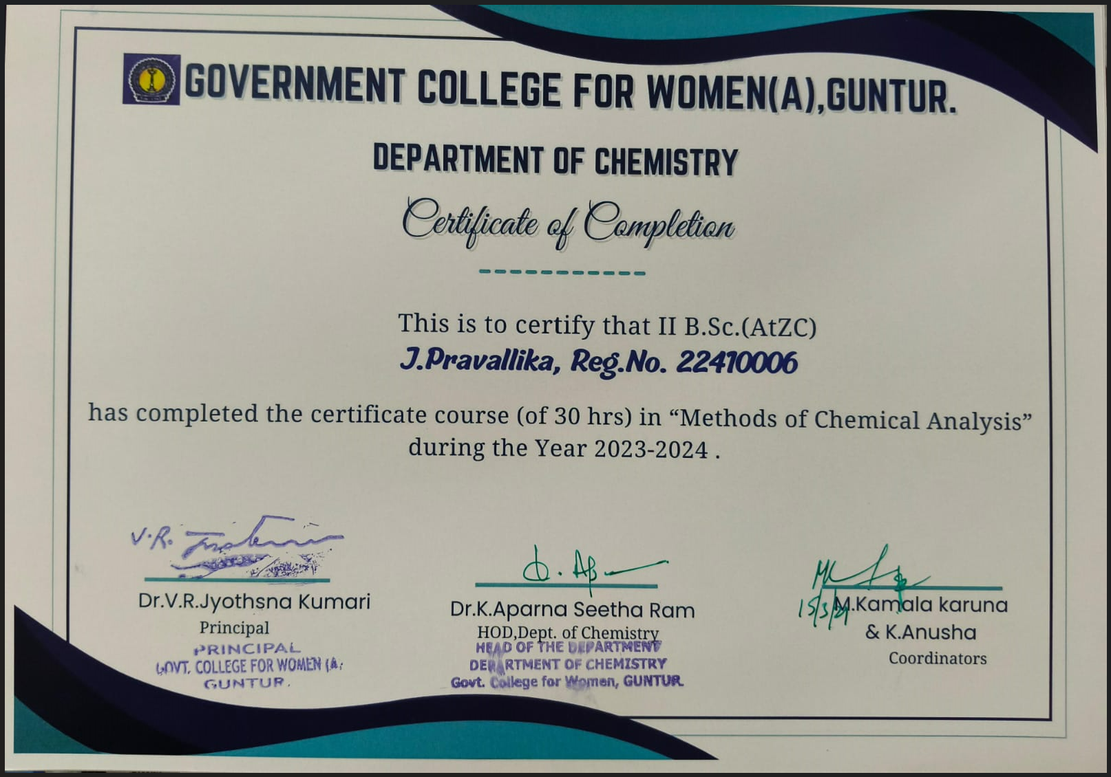
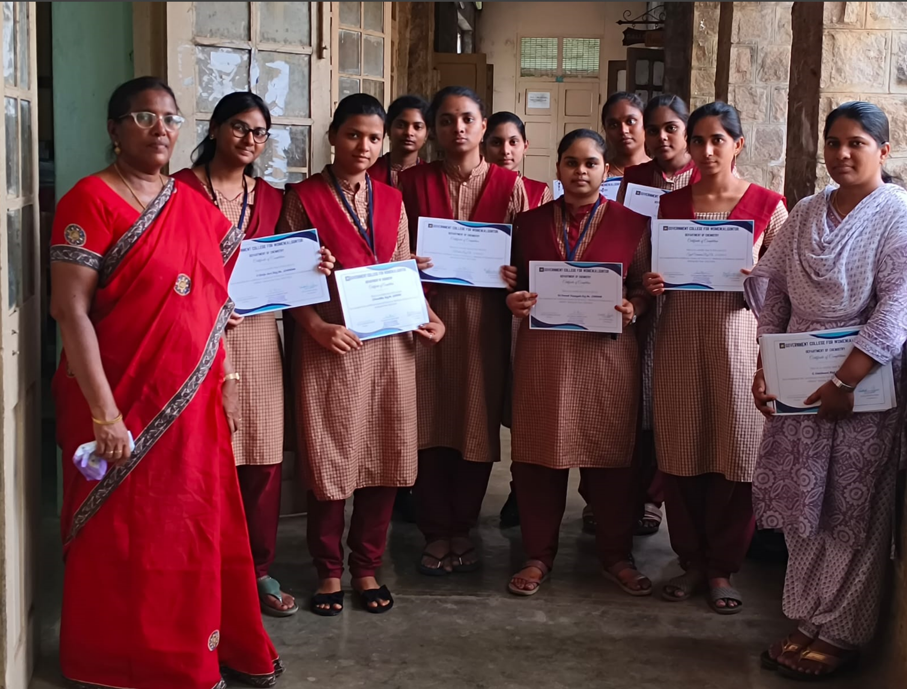
-End of the report

